
Medication Adherence Tracker for Elderly Patients
A CASE STUDY ANALYSIS REPORT
Submitted in the partial fulfilment for the Course of
CSA1012-Software Engineering
to the award of the degree of
BACHELOR OF TECHNOLOGY
IN
Artificial Intelligence
Submitted by
P SADVIK(192472243)
Under Supervision of
Dr. k Anita Davamani
SIMATS ENGINEERING
Saveetha Institute of Medical and Technical Sciences
Chennai-602105
AUGUST-2026

Abstract
Medication management becomes difficult when an elderly person has to remember several medicines at different times of the day. The problem becomes more serious when the person lives alone and family members are not available to check every dose. The Medication Adherence Tracker for Elderly Patients with Caregiver Alerts was planned to address this problem through a simple application that reminds the patient, records the dose status and informs a caregiver when a dose is missed.
This report presents the code review and repository evaluation of the project. The review looks at the way the project can be divided into modules, how the repository is arranged, how Git is used to track changes, and how the application can be tested. Special attention is given to the patient interface because the target users are elderly people who may not be comfortable with complicated mobile applications.
The review found that separating the user interface, backend services, database, tests and documentation makes the project easier to understand and maintain. A feature-based Git workflow also makes it easier to work on individual functions without disturbing the stable version. The main improvements suggested are better automated testing, proper handling of passwords and API keys, clearer documentation, and regular code review before merging changes.
Keywords: medication adherence, elderly care, caregiver alerts, code review, Git, repository, software testing, maintainability.

List of Figures
Figure | Title
Figure 1 | System Architecture
Figure 2 | Patient Medication Interface
Figure 3 | Repository Structure
Figure 4 | Git Workflow Used for the Project
Figure 5 | Testing and Validation Process

1. Problem Overview

1.1 Background
The project was selected because medication schedules can become difficult to follow when a patient has more than one prescription. A missed dose may not be noticed immediately by a family member or caregiver. Traditional reminders such as paper notes or ordinary pill boxes help the patient remember, but they do not provide a simple way for another person to know whether the medicine was actually taken.
The proposed tracker connects the patient and caregiver through a common system. The patient receives a reminder at the scheduled time and can confirm the dose using a simple action. The caregiver can then view the status. If the patient does not respond within the defined period, the system can raise an alert.

1.2 Main Objectives
- Provide a simple interface with large text and clear buttons.
- Allow medication schedules to be entered and updated.
- Send reminders at the correct time.
- Record whether a scheduled dose was taken or missed.
- Show adherence information to the caregiver.
- Generate an alert after a missed-dose time limit.
- Provide refill reminders when the medicine quantity is low.
- Protect patient information through authentication and access control.

1.3 Main Functional Requirements
Module | Requirement
Login | Patient and caregiver users should be authenticated.
Medication | User should be able to add medicine name, dose and schedule.
Reminder | A reminder should appear when a medicine is due.
Confirmation | Patient should be able to mark the dose as taken.
Missed Dose | A pending dose should become missed after the defined threshold.
Caregiver Alert | Caregiver should receive an alert for a missed dose.
History | Past dose records should be available for review.
Refill | Low medicine quantity should generate a refill reminder.
2. System Design and Repository Organization

2.1 System Architecture
The application can be viewed as a set of small parts rather than one large program. The patient interface communicates with the backend, while the backend handles medication schedules, dose records and caregiver alerts. The database stores user, medication and adherence information.
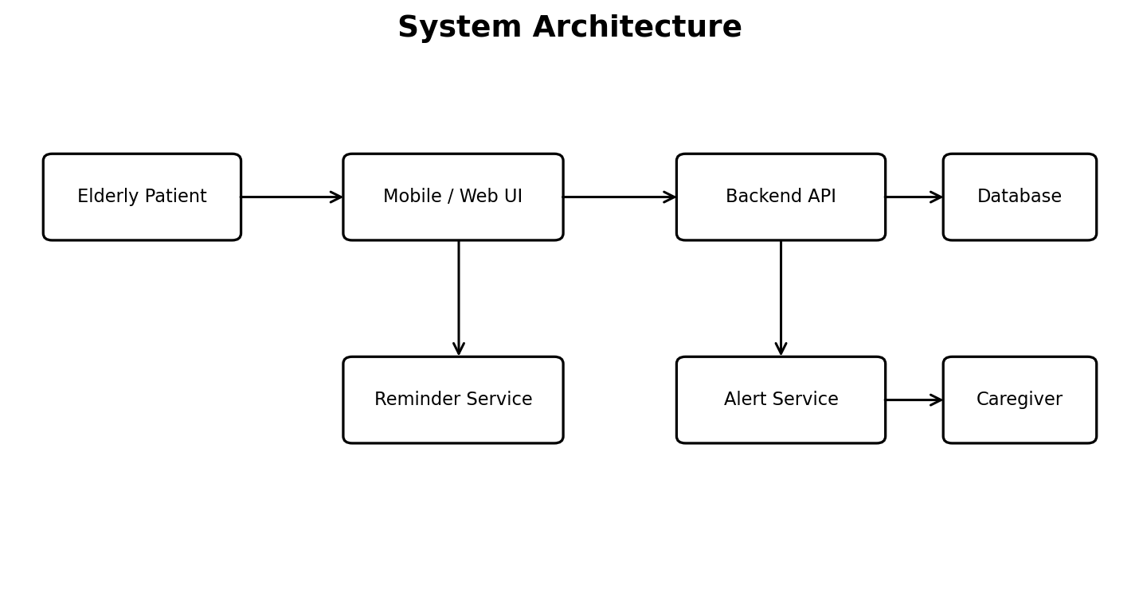
Figure 1. System Architecture of the Medication Adherence Tracker.

2.2 Patient Interface
The patient side is intentionally kept simple. The main screen should show only the information that is needed at that moment. For example, medicines due in the morning can be displayed first, with a large button for confirmation. The design avoids unnecessary menus and small text.
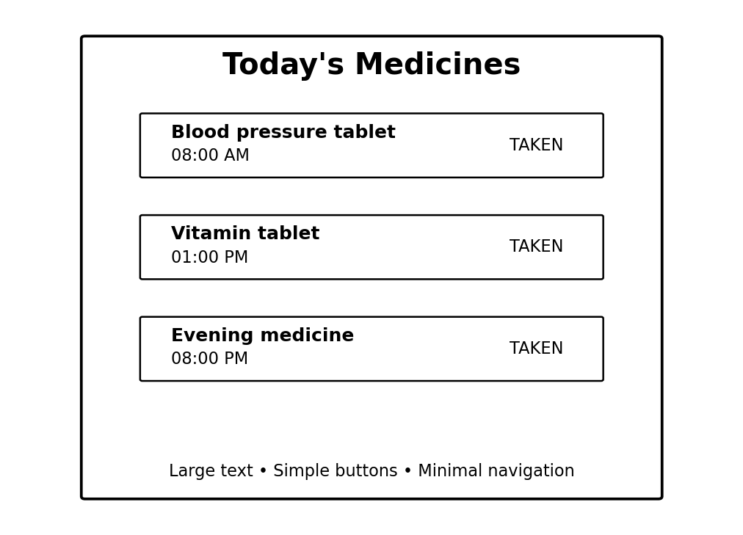
Figure 2. Example of a simplified patient medication interface.

3. Repository Organization

3.1 Folder Structure
medication-adherence-tracker/
├── frontend/
├── backend/
│ ├── routes/
│ ├── services/
│ └── database/
├── tests/
├── docs/
├── screenshots/
├── Dockerfile
├── docker-compose.yml
├── .gitignore
└── README.md
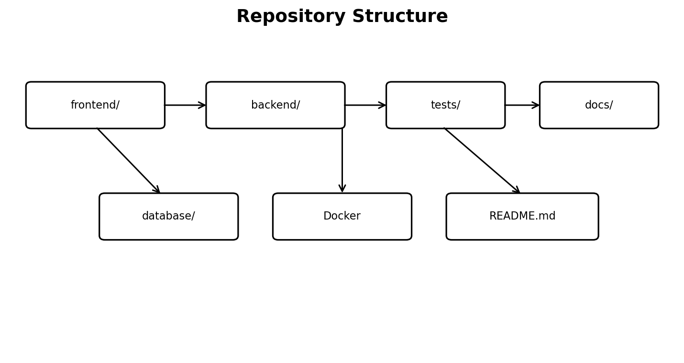
Figure 3. Proposed repository structure for the project.

3.2 Purpose of the Main Folders
Folder/File | Purpose
frontend/ | Patient and caregiver screens.
backend/ | Server-side application logic.
routes/ | Handles API requests.
services/ | Contains reminder, alert and business logic.
database/ | Database connection and schema-related files.
tests/ | Unit and integration tests.
docs/ | Project notes, architecture and setup details.
screenshots/ | Evidence used in the technical report.
Dockerfile | Instructions for creating the application image.
docker-compose.yml | Configuration for running application services.
README.md | Basic project information and setup instructions.

3.3 Repository Naming
File and folder names should be written in a consistent style. A developer opening the repository should be able to understand the purpose of a file without opening every file. For example, medication_service, caregiver_alert_service and refill_service are clearer than names such as service1 or final_code.

4. Code Quality Review

4.1 Readability
The code should be written so that another student or developer can understand it after some time away from the project. Functions should have one clear purpose. Long functions that perform database work, notification work and interface logic at the same time should be divided into smaller functions.

4.2 Modularity
Medication scheduling and caregiver alerts are related, but they should not be implemented as one large block of code. Keeping these functions in separate service modules makes later changes easier. For example, the alert time threshold can be changed without rewriting the medication scheduling module.
def check_missed_dose(dose, current_time):
if dose.status == "Pending" and current_time > dose.deadline:
return "Missed"
return dose.status
The above example is intentionally small. It shows that the missed-dose decision can be kept in one place instead of being repeated in several screens.

4.3 Code Review Checklist
Review Point | Observation | Suggested Action
Naming | Names should explain their purpose. | Use consistent naming.
Functions | Avoid very large functions. | Split by responsibility.
Validation | User input needs checking. | Validate before database operations.
Errors | Failures should not expose sensitive data. | Use controlled error messages.
Security | Passwords and keys should not be stored in source code. | Use environment variables/secrets.
Comments | Comments should explain non-obvious logic. | Avoid unnecessary comments.

5. Version Control Evaluation

5.1 Git Repository Initialization
Git is used to keep a history of the project. The repository can be initialized at the project root and the initial structure can then be committed. After that, individual features are developed on separate branches.
git init
git add .
git commit -m "Create initial project structure"
git branch -M main
git status

5.2 Branching Strategy
For this project, a simple main-development-feature workflow is suitable. The main branch represents the stable version. Development contains work that is being combined, while feature branches are created for individual functions such as medication scheduling or caregiver alerts.
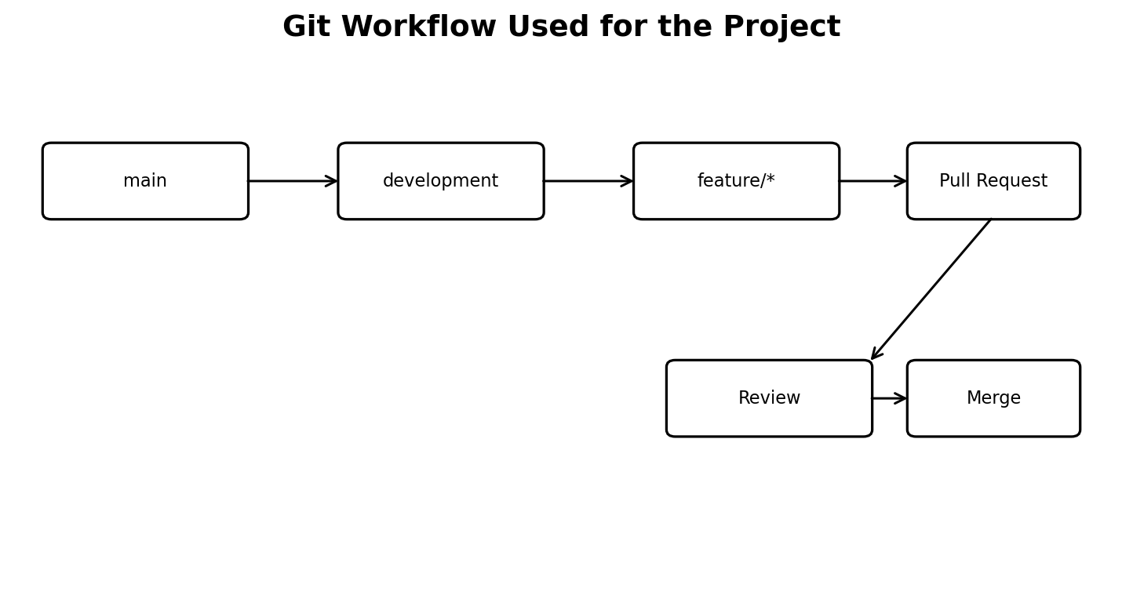
Figure 4. Git workflow used for feature development and review.

5.3 Example Commit History
Commit | Message | Purpose
e521a10 | Create initial project structure | Initial repository setup
f641c20 | Add user authentication | Login and access control
a761d34 | Add medication scheduling | Medication schedule module
b832e21 | Implement reminder service | Due-dose reminders
c392a11 | Add caregiver alerts | Missed-dose notification
a821f45 | Add Docker configuration | Containerized deployment

6. Version Control Workflow

6.1 Meaningful Commits
Commit messages should describe what was changed. Messages such as 'changes done' or 'final update' are difficult to understand later. A message such as 'Fix caregiver alert threshold' immediately tells the reviewer what was changed.

6.2 Merge and Review
- Create a feature branch from the development branch.
- Implement the feature and test it locally.
- Commit the change with a meaningful message.
- Push the branch to the remote repository.
- Create a pull request or request a review.
- Correct review comments and run the tests again.
- Merge the approved change into the development branch.

6.3 Repository Synchronization
git pull
git checkout -b feature/medication-schedule
git add .
git commit -m "Add medication schedule form"
git push -u origin feature/medication-schedule
This workflow gives a clear record of who made a change and why it was made. It also makes it possible to return to an earlier version if a new change introduces a problem.

6.4 Good and Poor Commit Messages
Better | Avoid
Add missed-dose detection | update
Fix medication schedule validation | some changes
Add caregiver dashboard tests | final code
Update Docker configuration | done

7. Code Testing and Validation

7.1 Testing Approach
Testing is important because a reminder system must behave correctly at the scheduled time. A small error in the time comparison could mark a dose as missed too early or fail to generate an alert. Testing should therefore cover normal use as well as incorrect input and failure cases.
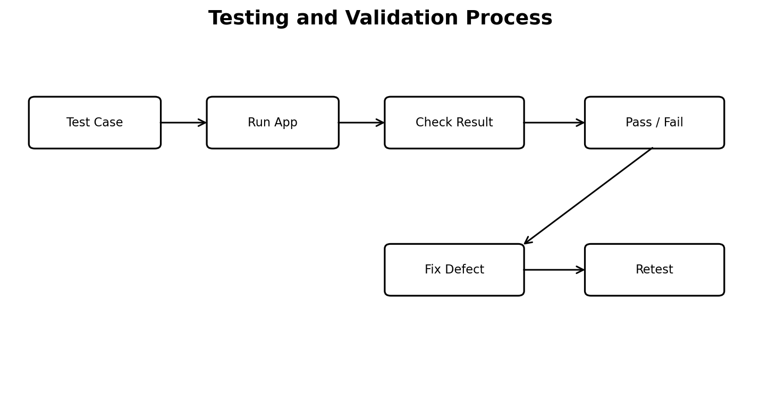
Figure 5. Testing and validation process.

7.2 Test Cases
ID | Test Case | Expected Result
TC01 | Login using valid details | User enters the correct dashboard.
TC02 | Login using invalid details | Access is rejected.
TC03 | Add a medication schedule | Medication is saved.
TC04 | Medication becomes due | Reminder is displayed/sent.
TC05 | Patient confirms dose | Dose status becomes Taken.
TC06 | Patient does not confirm | Dose becomes Missed after threshold.
TC07 | Dose is missed | Caregiver alert is generated.
TC08 | Medicine quantity becomes low | Refill reminder is generated.
TC09 | Unauthorized user opens protected data | Request is rejected.
TC10 | Database connection fails | Application handles the error safely.

7.3 Testing Evidence
- Screenshot of the application running.
- Screenshot of successful test execution.
- Git commit showing a bug fix.
- Docker container status and logs.
- Test result table included in the report.
8. Repository Documentation

8.1 README
The README is the first document a new developer normally checks. For this project it should briefly explain the problem, features, software requirements and how to run the application. It should not assume that the reader already knows the project.
# Medication Adherence Tracker
## Introduction
## Features
## Technology Used
## Project Structure
## Installation
## Database Configuration
## Running the Application
## Running Tests
## Docker Setup
## Troubleshooting

8.2 Documentation Quality
Document/Item | What it should contain
README | Overview, installation, usage and testing.
Architecture diagram | Main components and data flow.
Database notes | Tables and important relationships.
API notes | Available endpoints and request/response format.
Docker notes | Build and run commands.
Testing notes | Test cases and expected results.

8.3 Maintainability
Documentation should be updated along with code changes. If a new feature changes an API or database field, the README or technical notes should also be updated. Keeping documentation and source code in the same repository makes this easier.
9. Code Review Findings and Recommendations

9.1 Findings
Area | Finding | Priority
Project structure | Modules can be separated clearly. | High
Patient UI | Large text and simple actions suit the target users. | High
Business logic | Reminder and alert rules should remain in services. | High
Git | Feature branches make changes easier to review. | High
Testing | Core workflows have identifiable test cases. | High
Security | Credentials must be kept outside source code. | Critical
Documentation | README should cover setup and troubleshooting. | Medium
Automation | CI can reduce repeated manual checks. | Medium

9.2 Recommended Improvements
- Add automated unit tests for scheduling and dose-status logic.
- Add integration tests for caregiver alerts.
- Use environment variables for database credentials and API keys.
- Add a continuous integration workflow to run tests on every pull request.
- Use database migrations so schema changes can be tracked.
- Add API documentation for future integration.
- Add health checks to the Docker deployment.
- Perform a short code review before merging every major feature.

9.3 Security Review
Because the project deals with medication-related information, access control should be treated seriously. A caregiver should only see the patient records that they are authorized to monitor. Passwords should be stored using secure password hashing, and sensitive configuration values should not be committed to Git.

10. Docker and Deployment Review

10.1 Why Docker is Useful
Docker gives the project a repeatable environment. Instead of installing every dependency manually, the required application environment can be described in the Dockerfile. This is useful when the application is developed on one computer and tested on another.

10.2 Example Dockerfile
FROM python:3.12-slim
WORKDIR /app
COPY requirements.txt .
RUN pip install --no-cache-dir -r requirements.txt
COPY . .
EXPOSE 5000
CMD ["python", "app.py"]

10.3 Docker Compose
services:
app:
build: .
ports:
- "5000:5000"
environment:
- DATABASE_URL=${DATABASE_URL}
depends_on:
- db
db:
image: mysql:8
environment:
MYSQL_DATABASE: medication_tracker
MYSQL_ROOT_PASSWORD: ${DB_PASSWORD}
The database password is represented by an environment variable rather than placing a real password in the repository. In an actual deployment, secrets should be handled through the deployment environment or a dedicated secret-management service.

10.4 Deployment Checks
- Build the image without errors.
- Start the services using Docker Compose.
- Check container status.
- Check application logs.
- Open the application and run the main test cases.
- Stop and restart the services to confirm repeatability.

11. Overall Evaluation and Conclusion

11.1 Overall Evaluation
The Medication Adherence Tracker is a suitable project for demonstrating software engineering practices because it contains several independent modules and requires regular updates. The repository can be kept simple enough for student development while still following professional practices such as version control, testing, documentation and containerization.
From the code review point of view, the most important part is keeping the application understandable. A future developer should be able to find the medication logic, alert logic and database operations without searching through a single large file. The proposed folder structure supports this approach.

11.2 Final Assessment
Category | Assessment
Problem understanding | Clear and practical problem.
Functional design | Main patient and caregiver functions are identified.
Repository organization | Clear modular structure.
Code quality | Good foundation; consistency should be maintained.
Git usage | Feature-based workflow is appropriate.
Testing | Main workflows are covered; automation can be improved.
Documentation | Basic structure is provided; details should be kept updated.
Docker | Useful for consistent development and deployment.
Maintainability | Good when modular structure and review practices are followed.

11.3 Conclusion
The code review confirms that the project can be maintained effectively when the source code, repository and development process are kept organized. The combination of a simple elderly-friendly interface, caregiver monitoring, Git-based version control, testing and Docker provides a practical software engineering solution. The next stage of improvement should focus on automated testing, secure deployment, continuous integration and stronger documentation.

